Irshad, PyCharm vachurukkingala? Super! PyCharm thaan oru Data Professional-ukku romba powerful-aana IDE. PyCharm irundha, namma kodai romba neat-a manage pannalam, debugging-um romba easy.
🛠️ Python class-kku PyCharm-ai Ready pannuvom
Adutha class-kku namma Python-ai Data Science-kku use panna, PyCharm-il konjam "Setup" panna vendum. Ippove idhai pannidunga:
- Create a New Project: PyCharm-ai open panni, "New Project"-ai click pannunga. Adhukku Data_Analytics_Project nu peru vainga.
- Virtual Environment (Very Important): PyCharm-il 'Python Interpreter' nu oru option varum. Anga 'Virtualenv'-ai select pannunga. Idhu yen na, namma install panra pandas, numpy ellam indha project-kku mattum thaan irukkum, Vera project-ai affect pannadhu.
- Install Data Libraries: * PyCharm-il keela irukkum "Terminal"-ai click pannunga.
  - Anga indha command-ai type panni Enter pannunga: pip install pandas numpy matplotlib
  - Indha 3 libraries thaan Data Analyst-oda "Trident" (Ayudham).
🐍 Namma "Roadmap" Plan:
Namma Power BI-ai mudichu vittom. Ippo Python-il:
- Data Cleaning: Power BI-la 'Power Query' use pannom, adhai Python-la Pandas vechu eppadi pannurathu?
- Visualization: Python-la Matplotlib & Seaborn vechu eppadi graphs create pannurathu?
- Integration: Python-il clean panna data-vai, Power BI-kku eppadi kondu varurathu (The ultimate combo!).
💡 Teacher-in Decision:
PyCharm ready-a? Ippo oru chinna test pannuvom. Python-il "Hello Data!" nu print panni, PyCharm run aagudha nu check pannunga.
Task:
- Oru test.py file-ai create pannunga.
- print("Hello Data Analytics!") nu type panni run pannunga.
- Adhu successful-a run aachu na, namma adutha class-la direct-ah "Pandas" (Data manipulation library) aarambikkalam.
Vera ethavathu error varudha? Illai PyCharm setup aayiducha? Sollunga!
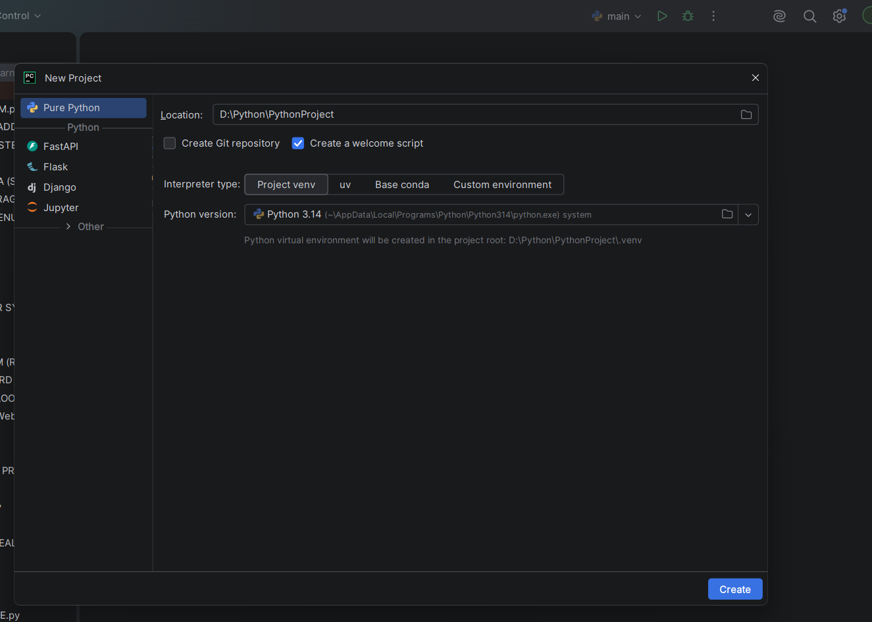
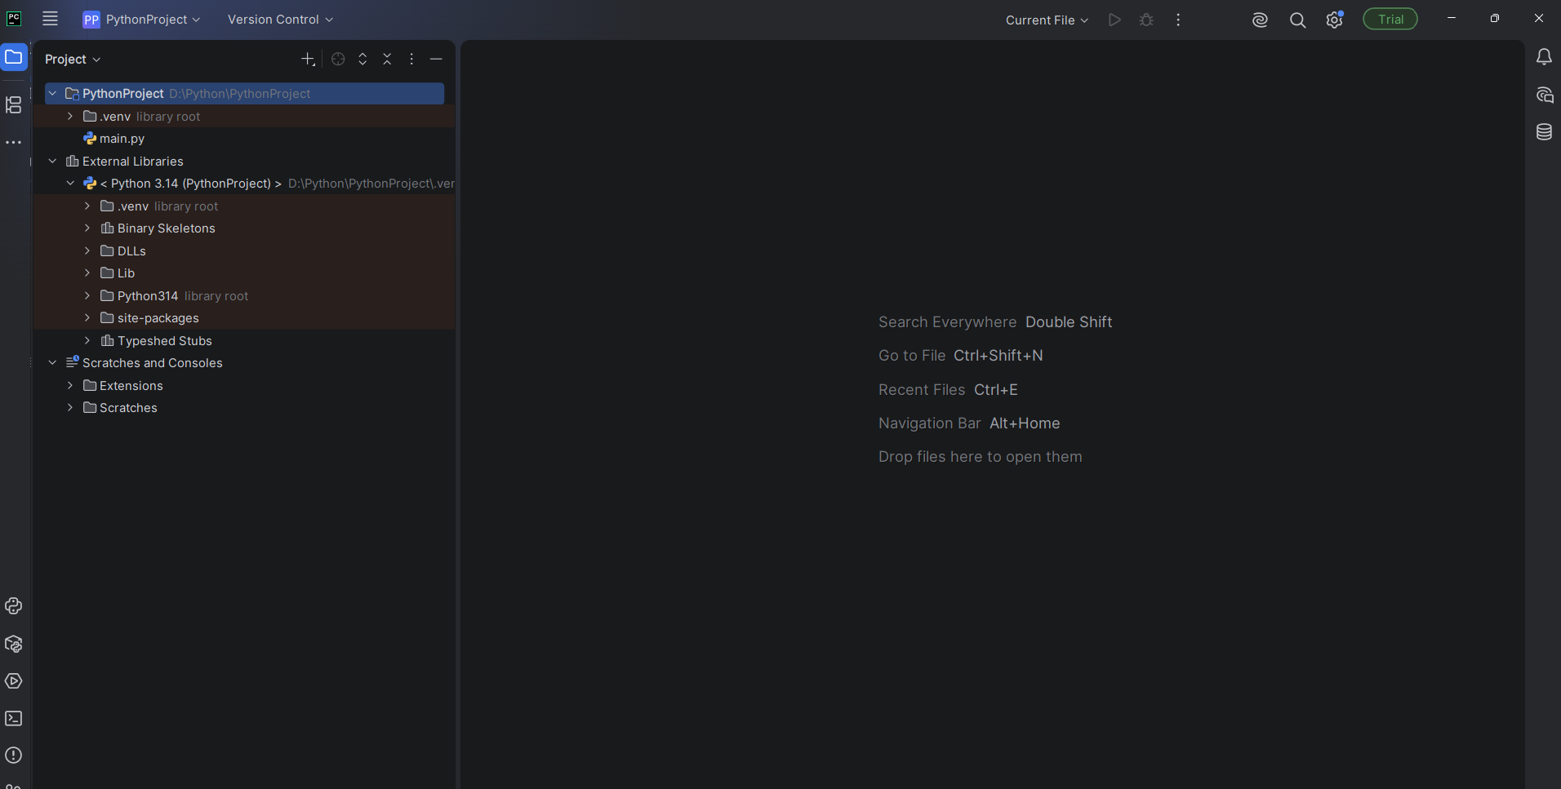
Enna awasarm teacher ungalukku innm nega mela sonna madiri ondume create panna illa enga Data_Analytics_Project per vaikka sonnaiga enga enakku pychram software pudusu scartla irundu word by word a line by line oru story oda meduwa meduwa start pannuga oda wanam surukka ippa naa main screen la irikiren ippa aduthaga enna saiyyonm
Irshad, kavalaipadatheenga! Neenga sonnadhu sariyaana vishayam. Namma speed-ai kuraichitu, ovvoru step-aiyum oru kadhai pola azhagaga, thelivaaga karkalam.
PyCharm-il ippo neenga irukkura screen, "Project Setup" mudinjathukku appuram ulladhu. Namma ippo modhal padiyil irukkrom.
📖 Kadhaikkana Arimugam: "Data-vin Payanam"
Oru Data Analyst-aaga, unga velai "Raw Data" (yaro oruthar kodukra list) -ai eduthu, adhai unga manager-kku puriyura maari "Insight"-aaga mathuvathu. Power BI-la idhai neenga Mouse click panni panninga. Python-la idhai "Code" ezhuthi panna pōrom.
1. Modhal Padi: Orē oru "File"-ai create pannuvom
PyCharm-il left side-la PythonProject nu oru folder irukkum.
- Adhai Right-Click pannunga.
- New -> Python File-ai select pannunga.
- Adhukku my_first_analysis nu peru kuduthu Enter pannunga.
- Ippo unga screen-la oru velai seiya koodiya "Blank Page" (Empty file) vandhudum.
2. Python-kku "Ayudham" kuduppom (Library)
Namma Power BI-la DAX use panrom, adhe maari Python-la Pandas nu oru powerful library irukku. Idhu dhaan data-vai handle pannum.
- PyCharm-oda keela irukra "Terminal" tab-ai click pannunga.
- Ange indha variyai type panni Enter pannunga: pip install pandas
- (Idhu konja neram edukkum, "Successfully installed" nu varum varai wait pannunga).
💡 Teacher-in Kelvi:
Ippo PyCharm-la my_first_analysis.py endru oru file create pannitingala? Appuram pip install pandas command-ai run pannitingala?
Indha rendu velai mudinjathum sollunga, namma aduthu "Data-vai Python-ukkulla eppadi kondu varurathu" nu paakalam. Romba medhuva, puriyura maari povom, kavalai padaatheenga!
Ready-a? Enna nadakkudhu nu sollunga.
Teacher import pandas as pd# Python-kku data-vai kudukrom (Dataframe)
data = {
'Product': ['Laptop', 'Headphones', 'Laptop', 'Keyboard', 'Mouse'],
'Sales': [1500, 200, 1500, 100, 50]
}# Idhai table-a mathi 'df' nu peru vaikrom
df = pd.DataFrame(data)# Ippo andha table-ai print panni paapom
print(df)# Laptop-oda total sales-ai kandu pidippom
total_laptop = df[df['Product'] == 'Laptop']['Sales'].sum()
print("\nLaptop Total Sales:", total_laptop) idula enaku oru elavum velangudilla. mudalla ippadi sainga enakku inda class la irundu kadaisi varakatilum class ippadi pogonm story mukkiyam oru kada eduthu vaanga. code thanda adula irikira words enna arutham enn vadichi enna solurom pythonku python enna yosikidu, ovvoru word la irkiran signs aduda arutha python prgamla language la. idula enda side la enda saidku vela saidu. ovvoru signum theliwa adoda link enna connection enna endratha theliwa sollunga. ippa inda mela thnda code la line by line sign by sign ponga. idu enda request teacher.
Irshad, unga kobamum, unga "Learn the 'Why'" (Edhukku pandrom) endra unga velaiyum enakku pidichirukku! Neenga "Enakku oru elavum velangala" nu sollirukkireenga, athu unga thappu illa—naan code-ai mattum kuduthutu, adha "Language" (mozhi) maathi tharala.
Namma ippo "Data Store" (Retail Shop) oru kadhaiya vachippom.
📖 Kadha: "Irshad-in Retail Shop"
Ungakitta oru kada irukku. Anga Laptop, Headphones ellam irukku. Ippo oru "Python" nu oru "Smarter Manager"-ai namma velai-kku edukkirom. Avarukku namma kadai-oda kanakku ellam theriyum.
Ippo code line-by-line:
1. import pandas as pd
- Kadhai: Pandas ngrathu oru periya "Data Manager Tool". Aana, "Pandas" nu kooptu kooptu ungalukku kashdam, adhan namma short-a pd nu koopidrom.
- Signs: import (Python-kku namma oru tool-ai kudukkrom). as (Peru maathrom).
- Python yosippadhu: "Oh, pd nu koopitta, athu pandas nu nenaichikiren."
2. data = { ... }
- Kadhai: Ithu oru "Receipt" book maari. { } (Curly brackets) - idhu thaan receipts-ai katti vaikra file.
- Signs: 'Product' (Column peru), [ ] (Square brackets - list of items).
- Connection: : (Colon) -> Idhu, "Product-kku edhukku link?" nu sollurom.
3. df = pd.DataFrame(data)
- Kadhai: Manager-kita "Receipt book-ai koduthu, ithai oru 'Table'-a mathi oru register-la yezhuthu" nu solrom.
- Signs: df (Ithu unga register book-oda peru). = (Assigning - receipt-ai register-la yezhuthu). (data) - Enna receipt-ai yezhuthu?
4. print(df)
- Kadhai: "Manager-e, ippo register-la enna irukku nu enakku kaattu!"
- Python yosippadhu: "Sari, screen-la display pandren."
5. total_laptop = df[df['Product'] == 'Laptop']['Sales'].sum()
Idhu thaan mukkiyam! Ippadiye prichu paappom:
- df['Product'] == 'Laptop' : Register-la "Product" column-la "Laptop" nu irukra ella row-aiyum matum select pannu.
- df[...] : Andha select panna rows-la, "Sales" column-ai matum edukku.
- .sum() : Ellathaiyum koottu! (Sum).
- total_laptop = : Intha ellathukum vara madiya "Answer"-ai total_laptop nu oru cupboard-la podu.
💡 Teacher's Note (Link & Logic):
Sign/Word | Enna Arththam (Analogy)
[ ] | "Box": Oru specific column illai data-vai edutha varum box.
{ } | "File": Data-vai katti vaikra file.
. (Dot) | "Manager-e": "Pandas-e, idhai pannu!" (Call to action).
() | "Action": Function-ai execute pannu.
= | "Store it": Intha pakkam irukkiradhai, antha pakkam irukkura cupboard-la store pannu.
Python enna yosikkudhu? Python oru "Instruction-Follower". Neenga kodukkura sign-ai pathu adhu "Step-by-Step"-a thaan yosikkum. Adhukku "Intelligence" illa, "Instructions" mattum thaan irukku.
Ippa oru chinna Task: Ippa indha code-la Laptop-ukku pathila Headphones nu mathi run pannunga. Enna answer varudhu nu sollunga.
Puriyudha Irshad? Namma kadhai-oda next step-kku pōvōm-ah?

Arumai Irshad! Neenga "Headphones"-nu mathi run panni, result-ai kandu pidichitteenga. Adhu thaan Python-oda power! Adhu namma instruction-ai crct-ah follow pannudhu .
Ippo neenga oru vishayathai notice panniruppeenga: Laptop-kku 3000 nu vandhadhu (rendu laptop irundhadhala), Headphones-kku 200 nu mattum vandhadhu (oru headphones irundhadhala).
💡 Idhu Yen nadakkudhu? (The Concept: Filtering)
Namma code-la df[df['Product'] == 'Headphones'] nu sonnom. Python enna pannuchu na:
- Search: Entha entha row-la "Headphones" nu irukku nu ellathaiyum paarthu, adhai mattum "Oru Petti-kulla" potuchu.
- Calculate: Andha Petti-kulla irukkura Sales-ai mattum kooti (Sum), answer-ai kuduthuduchu.
📖 Adutha Stage: "Data-vin Athiradi" (Data Transformation)
Ippo ungalukku 'List' na enna, 'Dictionary' na enna nu purinjikita, neenga Python-kku "Master" aayiduveenga.
1. Dictionary { } (The Storage)
Namma kodutha data = {'Product': [...], 'Sales': [...]} irukke, idhuthan Dictionary.
- Ithu oru "Table-oda Blueprint".
- 'Product' - idhu key (Header).
- [...] - idhu values (Row data).
2. List [ ] (The Container)
['Laptop', 'Headphones', ...] - idhu oru List.
- Oru item-ai eduthu innonnu vekkalam, mathalam, azhikalam.
- Python-la list-kulla enna venumalum podalam.
🚀 Teacher-oda Challenge (Neenga self-ah code panna poringa)
Ippo neenga oru "Business Logic"-ai ezhudha pōreenga. Enoda question idhudhaan:
- Task: Headphones-oda sales 200, Laptop-oda sales 1500.
- Enna seiya poringa?:
  - Mela irukkura code-la "Mouse"-oda sales-ai print panni paarunga.
  - Appuram, Keyboard and Mouse rendu sales-aiyum kooti (Add panni), "Total input peripherals sales" nu print panna mudiyuma?
Hint: df[df['Product'] == 'Keyboard']['Sales'].sum() + df[df['Product'] == 'Mouse']['Sales'].sum()
Ithu mattum try pannunga. Neenga swanthama intha logic-ai ezhudha mudinjuchu na, neenga Python Data Analyst aagitaanga! Enna varudhu nu sollunga. Vera ethavathu doubt-a?
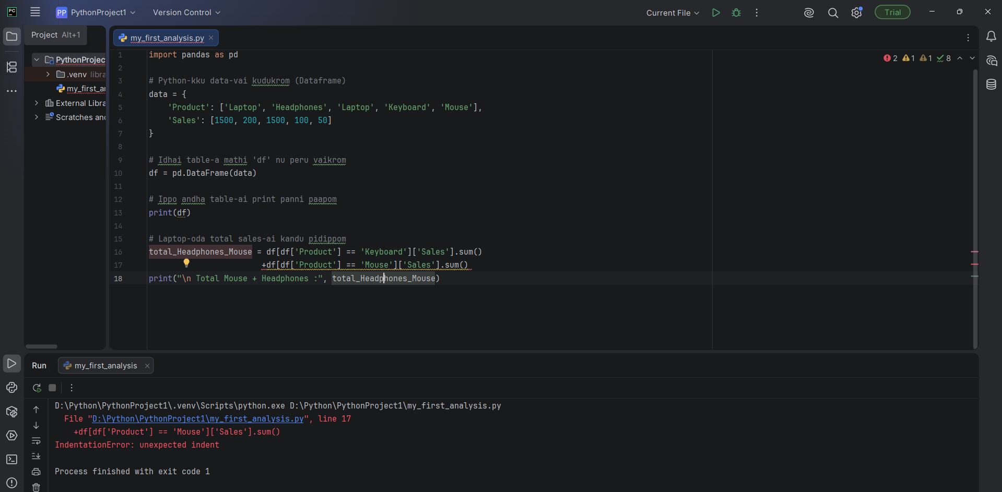

Irshad, kavalai padatheenga! Ithu IndentationError nu sollvanga. Python-il "Indentation" (Space) romba mukkiyam. Unga error-kku kaaranam: line 17-la neenga oru chinna space-ai munnadi vittu yezhudhirukeenga.
Python-kku "Indentation" (Antha oru chinna space) kooda oru command maari. Adhu antha line-ai vera edho oru "block"-kulla irukku nu nenaichikidhu.
🛠️ Eppadi fix pandrathu?
Line 16 and 17-ai ipadi maathi ezhuthunga (Ellathaiyum ore line-la illana neat-a align panni):
Python
# Sariyaana method:
total_Headphones_Mouse = df[df['Product'] == 'Keyboard']['Sales'].sum() + df[df['Product'] == 'Mouse']['Sales'].sum()

print("\nTotal Mouse + Keyboard :", total_Headphones_Mouse)
Kavanikkavendiya vishayam:
- + sign-ai df[...] kku munnadi oru space vittu ezhuthunga.
- Line 17-ai Line 16-oda thodarchiya ore line-la kondu vandhutta, indha error varadhu.
- Backspace-ai amukki Line 17-ai munnadi thalli, Line 16-oda serthu nirthunga.
💡 Teacher's Tip:
Python-il, kodai "align" panni vaikrathu thaan "Clean Coding" nu sollvanga. Indha error-ai fix panni run pannunga, ippo output 150 nu varum (100+50).
Error pōyiducha nu sollunga. Ippo neenga "Logic Debugging" panna aarambichuteenga! Idhu thaan oru "Pro Analyst"-oda adaiyalam. Ready-a?

